1. Gun Range + Quad biking Adventure
A high‑adrenaline combo perfect for thrill‑seekers, bachelor groups, and adventure travellers.
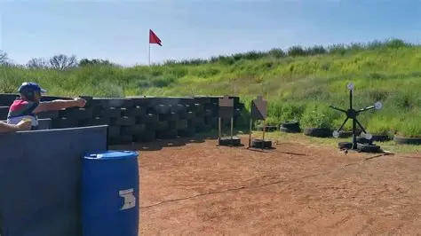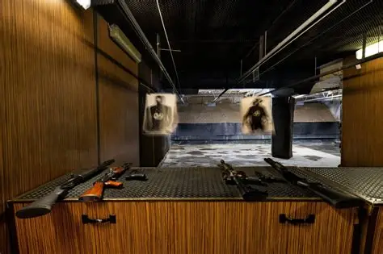
Tour Overview
Start with a fully supervised shooting experience at an accredited gun range, followed by a thrilling quadbike ride at the Atlantis Dunes.
Itinerary
- Pickup in Cape Town
- Shooting range session (handgun or rifle package)
- Drive to Atlantis Dunes
1‑hour quad biking adventure
Return to Cape Town
Inclusions
- Private transport
- Accredited shooting instructor
- Firearm safety briefing
- Quadbike rental & safety gear
- Bottled water
Exclusions
Meals
Optional photo/video packages
Price
2–4 guests: R9,800 total
5–7 guests: R13,400 total

